Time: 40 Minutes
Once I began writing the code things went well but it took me a while to figure out classes.

Output:
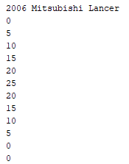

0 is outputted twice at the end to test an if statement that prevents speed from being negative.

